# **CTF Topic: Footprinting Using Have I Been Pwned**



# 

# 

# 

# **Introduction**

Have I Been Pwned (HIBP) is a website created by security expert Troy Hunt. It allows internet users to check if their data has been compromised by data breaches. Users can enter their email addresses or usernames, and the website will inform them if their information appears in any known data breaches.

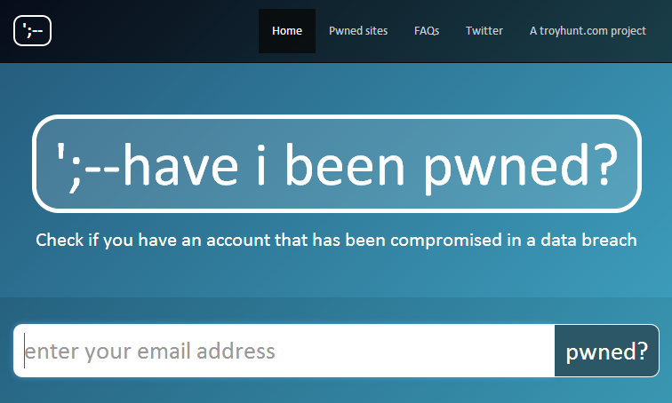

# **Tools and requirements**

1. Have i been pwned website

# **Scenario**



You are a concerned individual who wants to check if your email address has been compromised. Your task is to use Have I Been Pwned to determine if your email address has been involved in any data breaches and identify one specific breach if it exists.

# **Process**

1. Go to your chrome and click on the provided link: <https://haveibeenpwned.com/>
2. It will open and enter the email [john@gmail.com](mailto:john@gmail.com)
3. Check whether it is pwned or not.

# **Question**

Flag 1: Is the email john@gmail.com pawned?

Answer: Yes

Flag Captured.

Flag 2: In March 2015, What was the number of customer record data exposed?

Answer: 15 million

Flag Captured

# **Hint**

